Worksheet No. - 2

Student Name: Sujal Dhiman UID: 25MCA20186
Branch: MCA Section/Group: 1A
Semester: 2nd Date of Performance: 6th Jan, 2026 Subject Name: TECHNICAL TRAINING Subject Code:25CAP-652

Aim/Overview of the practical:
To implement and analyze SQL SELECT queries using filtering, sorting, grouping, and aggregation concepts in PostgreSQL for efficient data retrieval and analytical reporting.
Objective:
- To retrieve specific data using filtering conditions
- To sort query results using single and multiple attributes
- To perform aggregation using grouping techniques
- To apply conditions on aggregated data
- To understand real-world analytical queries commonly asked in placement interviews

Input/Apparatus Used:
  - PostgresSQL
  - pgAdmin Procedure/Algorithm/Code :
CREATE TABLE Students ( student_id INT,
name VARCHAR(50), city VARCHAR(50),
percentage DECIMAL(5,2)
);
INSERT INTO Students VALUES
(1, 'Arjun', 'Delhi', 92.4),
(2, 'Neha', 'Mumbai', 96.8),

(3, 'Sahil', 'Delhi', 98.3),
(4, 'Isha', 'Pune', 94.7),
(5, 'Rohit', 'Chandigarh', 97.1),
(6, 'Meena', 'Delhi', 95.9),
(7, 'Varun', 'Pune', 99.2);
--- Without Case Statement
SELECT CITY, COUNT(*) AS STUDET_COUNT
FROM Students WHERE percentage > 95 GROUP BY city;
-- WITH CASE STATEMENT SELECT CITY,
SUM(CASE WHEN percentage > 95 THEN 1 ELSE 0 END) AS STUDENT_COUNTS
FROM Students GROUP BY city;
-- (II)
SELECT CITY,
AVG(CASE WHEN PERCENTAGE > 95 THEN PERCENTAGE ELSE NULL END) AS STUDENT_AVG
FROM Students GROUP BY city
ORDER BY STUDENT_AVG DESC;

Output:
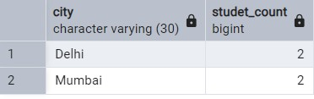
Without Case Statement

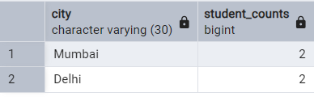
With Case Statement - I

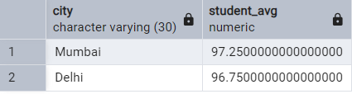
With Case Statement - II

Learning outcomes (What I have learnt):
- I have understood how data can be filtered to retrieve only relevant records from a database.
- I have learned how sorting improves the readability and usefulness of query results in reports.
- I have gained the ability to group data effectively for analytical purposes.
- I have clearly learned to differentiate between row-level conditions and group-level conditions.
- I have developed confidence in writing analytical SQL queries used in real-world scenarios.
- I have become better prepared to answer SQL-based placement and interview questions related to filtering, grouping, and aggregation.

